- Write a program to implement isEmpty method.

import java.util.Arrays;
class Sample
{
public static void main(String args[])
{
String s1="Anandha kumar";
String s2="";
System.out.println("EMPTY STRING= "+s1.isEmpty());
System.out.println("STRING IN= "+s2.isEmpty());
}
}
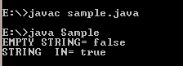

2. Write a program to implement split method.
import java.util.Arrays;
class Sample
{
public static void main(String args[])
{
String s1="Anandhakumar";
String s2[]=s1.split("");
for(String s:s2)
{
System.out.println("SPLIT= "+s);
}
System.out.println("SPLIT= "+Arrays.toString(s2));
}
}

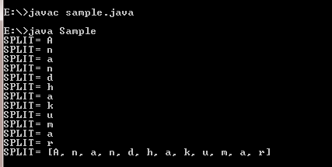

3.Write a program to implement trim method.
import java.util.Arrays;
class Sample
{
public static void main(String args[])
{
String s1=" Anandhakumar ";
System.out.println("TRIM= "+s1.trim()+";");
}
}
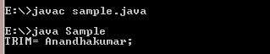

4. Write a program to implement subSequence & substring methods.
import java.util.Arrays;
class Sample
{
public static void main(String args[])
{
String s1="Anandhakumar ";
System.out.println("SUB SEQUENCE= "+s1.subSequence(2,5));
System.out.println("SUB STRING= "+s1.substring(7));
}
}
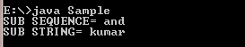

5. Write a program to implement valueOf method.

import java.util.Arrays;
class Sample
{
public static void main(String args[])
{
boolean b1 = true;
boolean b2 = false;
System.out.println("Boolean String valueOf= "+
String.valueOf(b1));
System.out.println("Boolean String valueOf= "+
String.valueOf(b2));

int a=15;
System.out.println("Integer String valueOf= "+ String.valueOf(a));

double d=998.56;
System.out.println("Double String valueOf= "+ String.valueOf(d));

long l=24136896;
System.out.println("Long String valueOf= "+ String.valueOf(l));

float f=98.1f;
System.out.println("Float String valueOf= "+ String.valueOf(f));

char c='c';
System.out.println("Char String valueOf= "+ String.valueOf(c));

char c1[]=new char[]{'c','d'};
System.out.println("Char Array String valueOf= "+ String.valueOf(c1));

Sample s=new Sample();
System.out.println("Object Array String valueOf= "+String.valueOf(s));

char c2[]=new char[]{'A','N','A','N','D'};
System.out.println("Char Array String valueOf= "+ String.valueOf(c2,2,3));

}
}
OUTPUT:
